¹Meshaal Mouawad
Mississippi State University, Electrical and Computer Engineering Department,
This is a summary report of my research assignments I was given by my advisor during my PhD program
Summary Report:
For Research Assignments of my PhD

Assignment I
Voronoi Diagram for Robot Navigation
Feb 23, 2021
T
He first Assignment is reading research papers and studying Voronoi Diagram for robot navigation. And read 3 research papers were given by my advisor. The papers are:

Chaomin Luo, Mohan Krishnan, Mark Paulik, Bo Cui, and Xingzhong Zhang, “A Novel LIDAR-driven Two-level Approach for Real-time Unmanned Ground Vehicle Navigation and Map Building”, SPIE2014.

Bhattacharya VD PP IEEE ISVD2007.PDF

Xiong VD ACO multiple robot RAS2019.PDF
2$→$ Please find some reading materials on Voronoi Diagram (VD) online. Here are some examples to study Voronoi Diagram for robot path planning.
3.$→$ Next week, or sooner, I will email your first project on VD for robot path planning using nature-inspired intelligence.
3.$→$ Read papers and study Voronoi Diagram for navigation.
4.$→$Next step, I will introduce you another bio-inspired optimal model for path planning, which will integrate with VD model.
A
Novel LIDAR-driven Two-level Approach for Real-time Unmanned Ground Vehicle Navigation and Map Building.
Main
Algorithms:
Voronoi diagram Algorithm
Obstacle Avoidance Algorithm (OAA).
Distinguish Algorithm (DA)
Vector Field Histogram (VFH) algorithm
Heuristic algorithm.
reactive local navigation algorithm
scout ant algorithm for vehicle navigation
Methods:
P
ath planning of multiple autonomous marine vehicles for adaptive sampling using Voronoi-based ant colony optimization.
• $→$A Voronoi-based ACO for multi-AMVs is introduced to solve adaptive sampling problem.
• $→$ Voronoi partition with tournament selection is applied as a pre-processing for ACO.
• $→$A modified heuristic function of ACO is proposed to facilitate searching solutions.
Algorithms:
Ant colony optimization (ACO), Dijkstra’s algorithm, graph search methods (Dijkstra’s algorithm [23], A* algorithm [24], field D* algorithm [25]), sample-based methods [26,27] (Probabilistic Roadmap Method (PRM), Rapidly-exploring Random Trees (RRT), etc.) and evolutionary algorithms [28] (genetic algorithm (GA), particle swarm optimization (PSO), ant colony optimization (ACO),
Methods:
Need to learn:
[path planning] Cubic B-spline for the formulation of candidate path from a set of control points is presented here. B-spline curve with characteristics of geometrical invariability, continuity, symmetry, recursion, convexity preserving is well fitted in evolutionary path planners [32].’

MATLAB Code Studying
The Code Procedure.
1 the code gets an input image and converts it into a graph.
2 the nodes in the GVD graph are Meetpoints and Endpoints.
3 the output is two graphs: a) Pixel Path Graph, b) Quadratic Curves Graph.
Parameters:
Inputs
InputImage = the map 'Map8_2.jpg'

Radius: it is radius of the robot, this parameter is used to compute configuration.
- Free space, in case if the graph is disconnected it means robot's radius is big and it can not pass through a narrow corridor or door in the map.

Resolution: this parameter is used to convert image space into real

Outputs
Graph: contains nodes and path between nodes (in pixel)
- path : n*2 matrix for x and y
- from : the corresponding start node
- to : the corresponding end node

Quadgraph: contains the graph in the form of quadratic function for each edge.
- number_nodes: number of nodes in the constructed graph
- node_list: location of the nodes
- edge_matrix: Adjacency matrix of the graph
- path_matrix: The Path between all the nodes
- w_s : size of the work space
- Pol_coefs: coefficent of the quadratic form of the edges

The function SHOWGRAPH shows how you can access tot the structures (GRAPH, QUADGRAPH).

SE = strel('disk',R,N) creates a flat disk-shaped structuring element
with the specified radius, R. R must be a nonnegative integer. N must
be 0, 4, 6, or 8. When N is greater than 0, the disk-shaped structuring
element is approximated by a sequence of N (or sometimes N+2)
periodic-line structuring elements. When N is 0, no approximation is
used, and the structuring element members comprise all pixels whose
centers are no greater than R away from the origin. N can be omitted,
in which case its default value is 4.
Note: Morphological operations using disk approximations (N>0) run much faster than when N=0. Also,
the structuring elements resulting from choosing N>0 are suitable for
computing granulometries, which is not the case for N=0. Sometimes it
is necessary for strel to use two extra line structuring elements in the
approximation, in which case the number of decomposed structuring
elements used is N+2.

Week 4

A
Utonomous exploration and navigation of an environment by a mobile robot is a difficult task involving the steps of mapping, localization and path planning.
1
Vector Field Histogram. The vector field histogram (VFH) algorithm computes obstacle-free steering directions for a robot based on range sensor readings. Range sensor readings are used to compute polar density histograms to identify obstacle location and proximity. Based on the specified parameters and thresholds, these histograms are converted to binary histograms to indicate valid steering directions for the robot. The VFH algorithm factors in robot size and turning radius to output a steering direction for the robot to avoid obstacles and follow a target direction.

Robot Dimensions
To calculate steering directions, you must specify information about the robot size and its driving capabilities. The VFH algorithm requires only four input parameters for the robot. These parameters are properties of the controllerVFH object: RobotRadius, SafetyDistance, MinTurningRadius, and DistanceLimits.
- RobotRadius specifies the radius of the smallest circle that can encircle all parts of the robot. This radius ensures that the robot avoids obstacles based on its size.
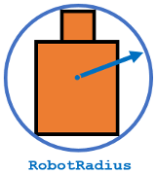
- SafetyDistance optionally specifies an added distance on top of the RobotRadius. You can use this property to add a factor of safety when navigating an environment.
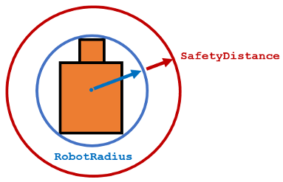
- MinTurningRadius specifies the minimum turning radius for the robot traveling at the desired velocity. The robot may not be able to make sharp turns at high velocities. This property factors in navigating around obstacles and gives it enough space to maneuver.
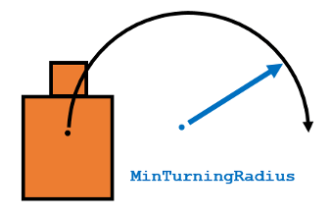
- DistanceLimits specifies the distance range that you want to consider for obstacle avoidance. You specify the limits in a two-element vector, [lower upper]. The lower limit is used to ignore sensor readings that intersect with parts on the robot, sensor inaccuracies at short distances, or sensor noise. The upper limit is the effective range of the sensor or is based on your application. You might not want to consider all obstacles in the full sensor range.
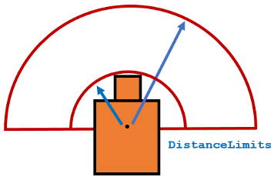

This Report was submitted in 2019 for Mississippi State University, Electrical and Computer Engineering Department during Fall 2019 foe the course of Introduction to Radars Engineering instructed by Dr. Ball John ¹Meshaal Mouawad, Mississippi State University, Starkville, MS 39759 USA (e-mail: mm4922@msstate.edu).

